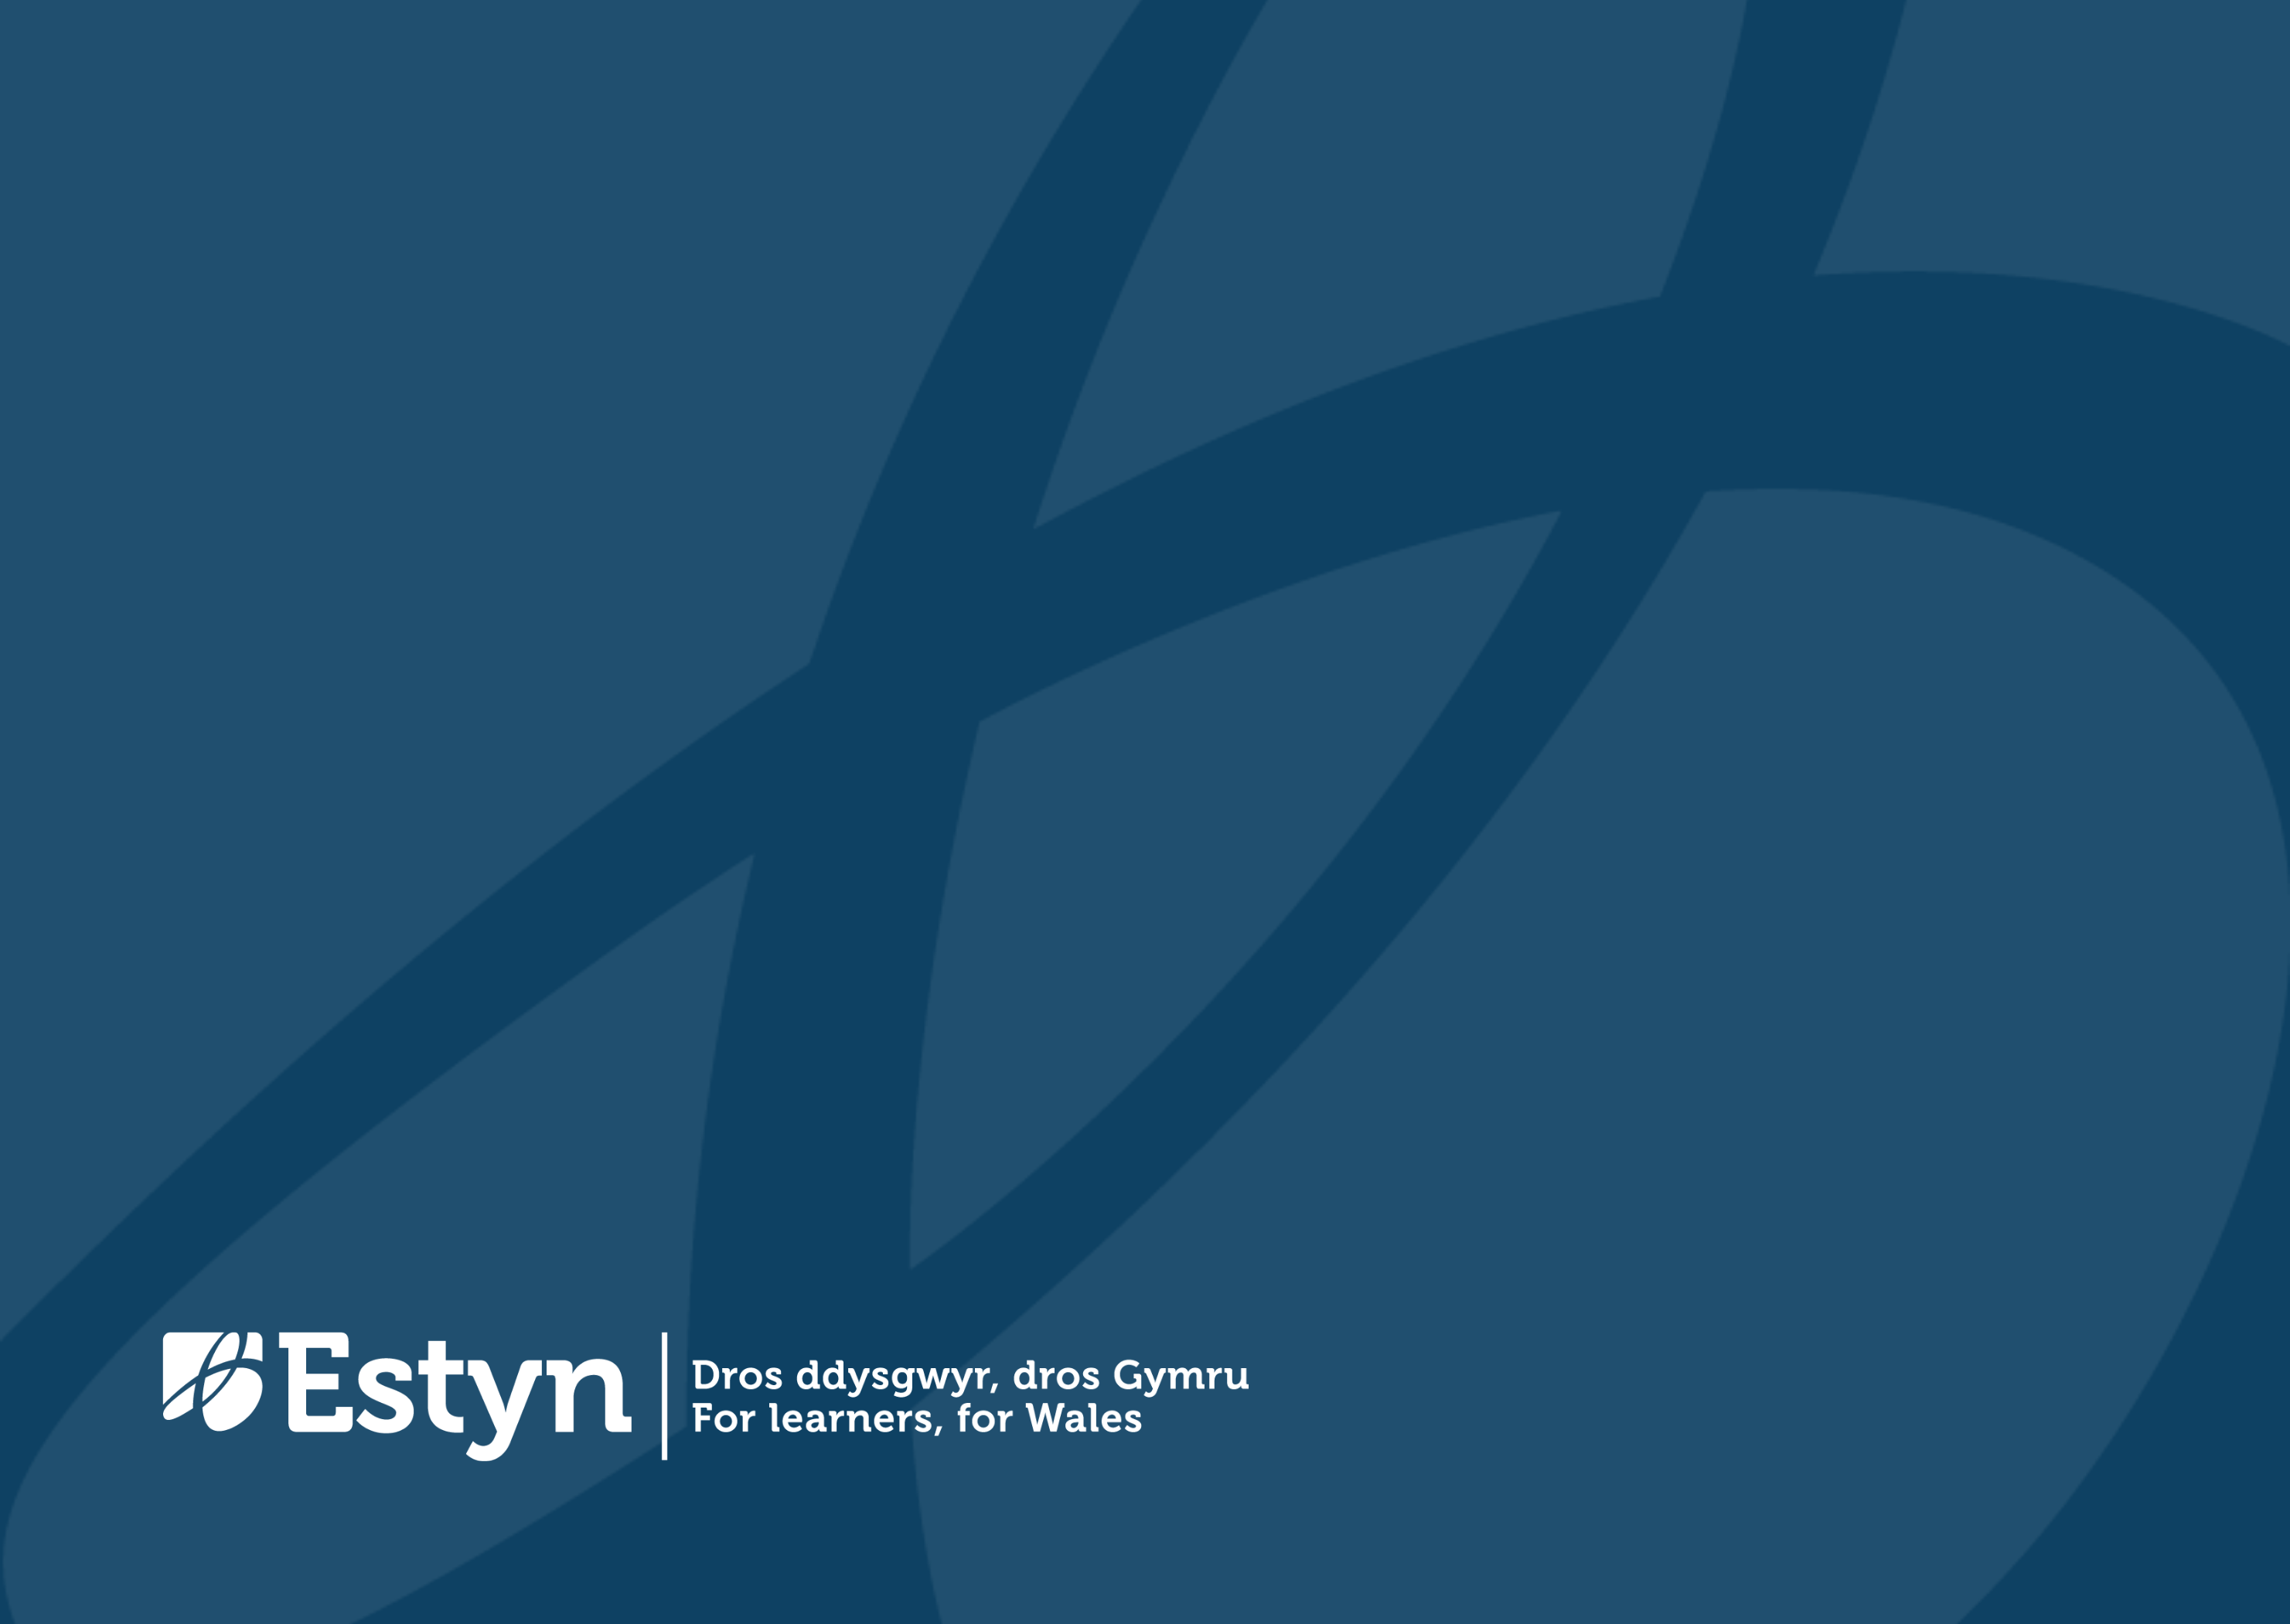
Welsh Speaking Digital Communications Officer

  - Information Pack

Closing Date: 9 February 2026

Duration: Permanent
Salary: £30,769 – £35,014 per annum

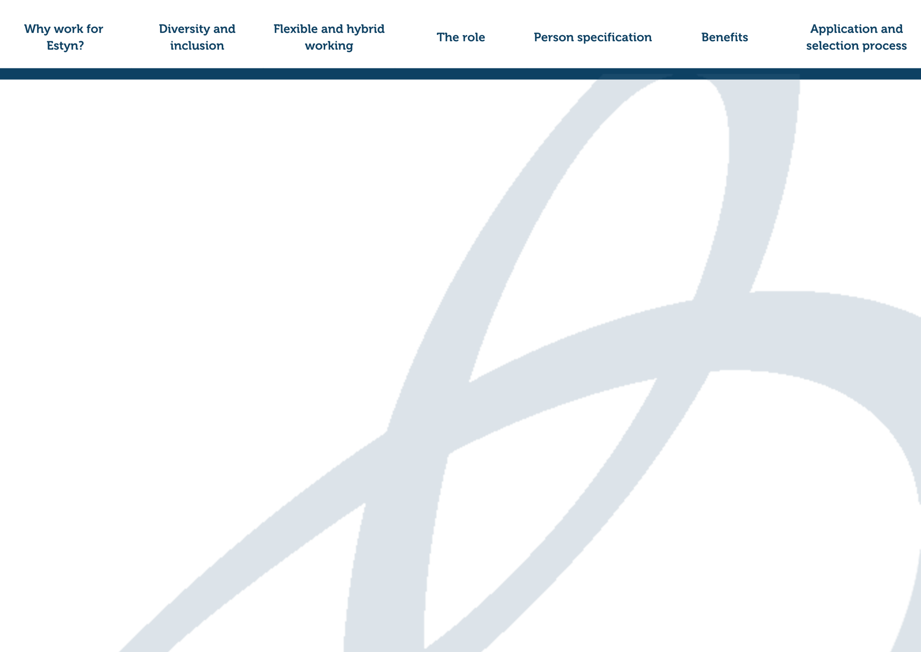
Welcome

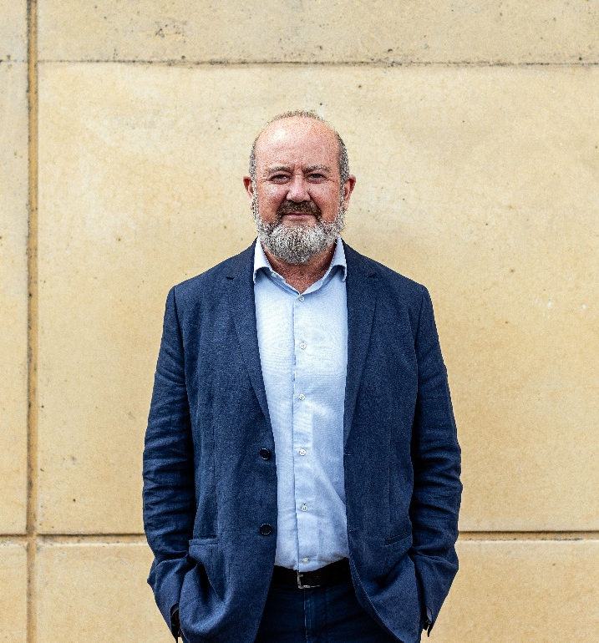
This is a great time to join us at Estyn. We’re actively supporting schools and other providers through exciting reforms in Welsh education. Our work makes a real difference to learners across Wales and at Estyn, they’re at the heart of everything we do.
Owen Evans, HMCI
We’re proud to play a vital role in improving education and training. Our people are passionate about what they do, and we work collaboratively to deliver high-quality services that promote accountability, support improvement, and help shape the future of learning in Wales.
We are looking for a creative and skilled Digital Communications Officer who can support the planning, delivery and evaluation of our communications, events and stakeholder engagement activity. The successful candidate will create engaging, accessible multimedia content that reaches our audiences and supports Estyn’s strategic aims. They will take responsibility for coordinating and maintaining accurate, user-friendly and accessible website and social content, and will bring strong experience in social media management, graphic design and video editing. Working closely with the Digital Communications Manager, PR & Campaigns Manager and colleagues across Estyn, they will help ensure all PR and marketing activity aligns with our wider strategic objectives. This is an excellent opportunity to make a valued contribution to Estyn’s work.
By joining us, you’ll become part of a forward-thinking and evolving organisation, one that’s committed to learning, improvement, and the development of its people. You’ll also gain access to opportunities across the wider Civil Service, giving you room to grow and shape your career.
This pack includes more information about what it’s like to work with us, details about the role, and guidance on how to apply.

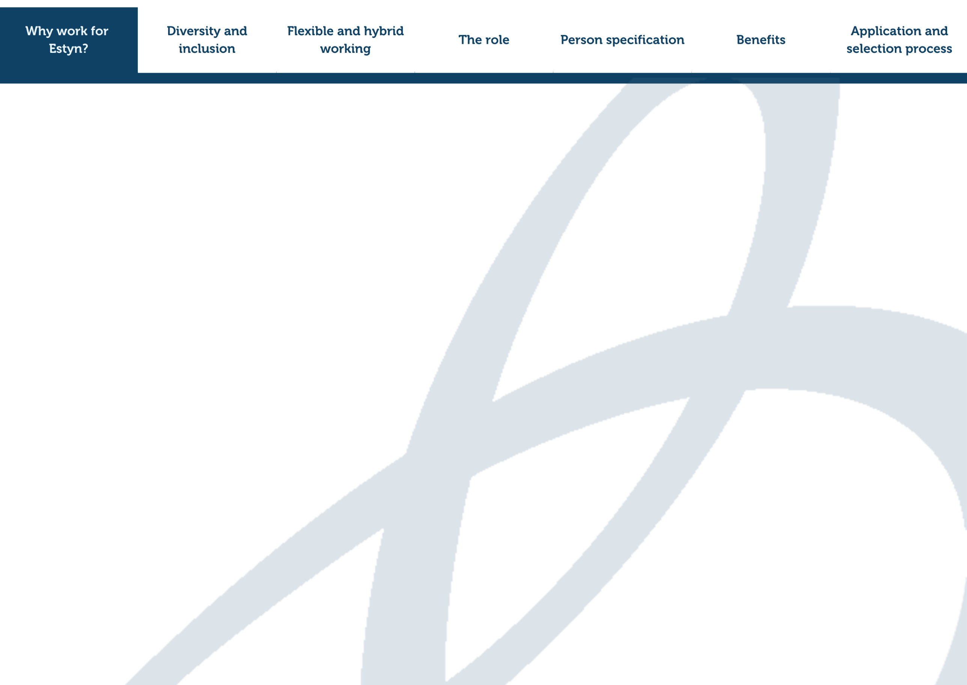
Why work for Estyn?

We are the education and training inspectorate for Wales. Our aim is to improve the quality of education and training for learners in Wales. One of our key roles is to inspect education and training in Wales to give assurance to the public and government regarding educational standards.

We help education providers, such as schools and colleges, to improve quality and outcomes. We also advise the Welsh Government about educational policy and prepare reports on a wide range of educational issues and themes. Further information on our work can be found here.

Our work makes a real difference to learners in Wales, and we know that it’s our dedicated team who help make that happen.

We believe in supporting and valuing every member of our team. From day one, you’ll be welcomed into a friendly, professional environment where your ideas and contributions matter. You’ll receive a thorough induction to help you understand how your role fits into our shared mission. You’ll be part of a collaborative network of colleagues, both within your team and across the wider organisation.

We’re committed to helping you grow. You’ll have access to a wide range of learning and development opportunities to build your skills and support your career journey, whether that’s through individual training or team development.

If you care about making a difference and want to work somewhere that supports your development and values your wellbeing, Estyn is a great place to work.

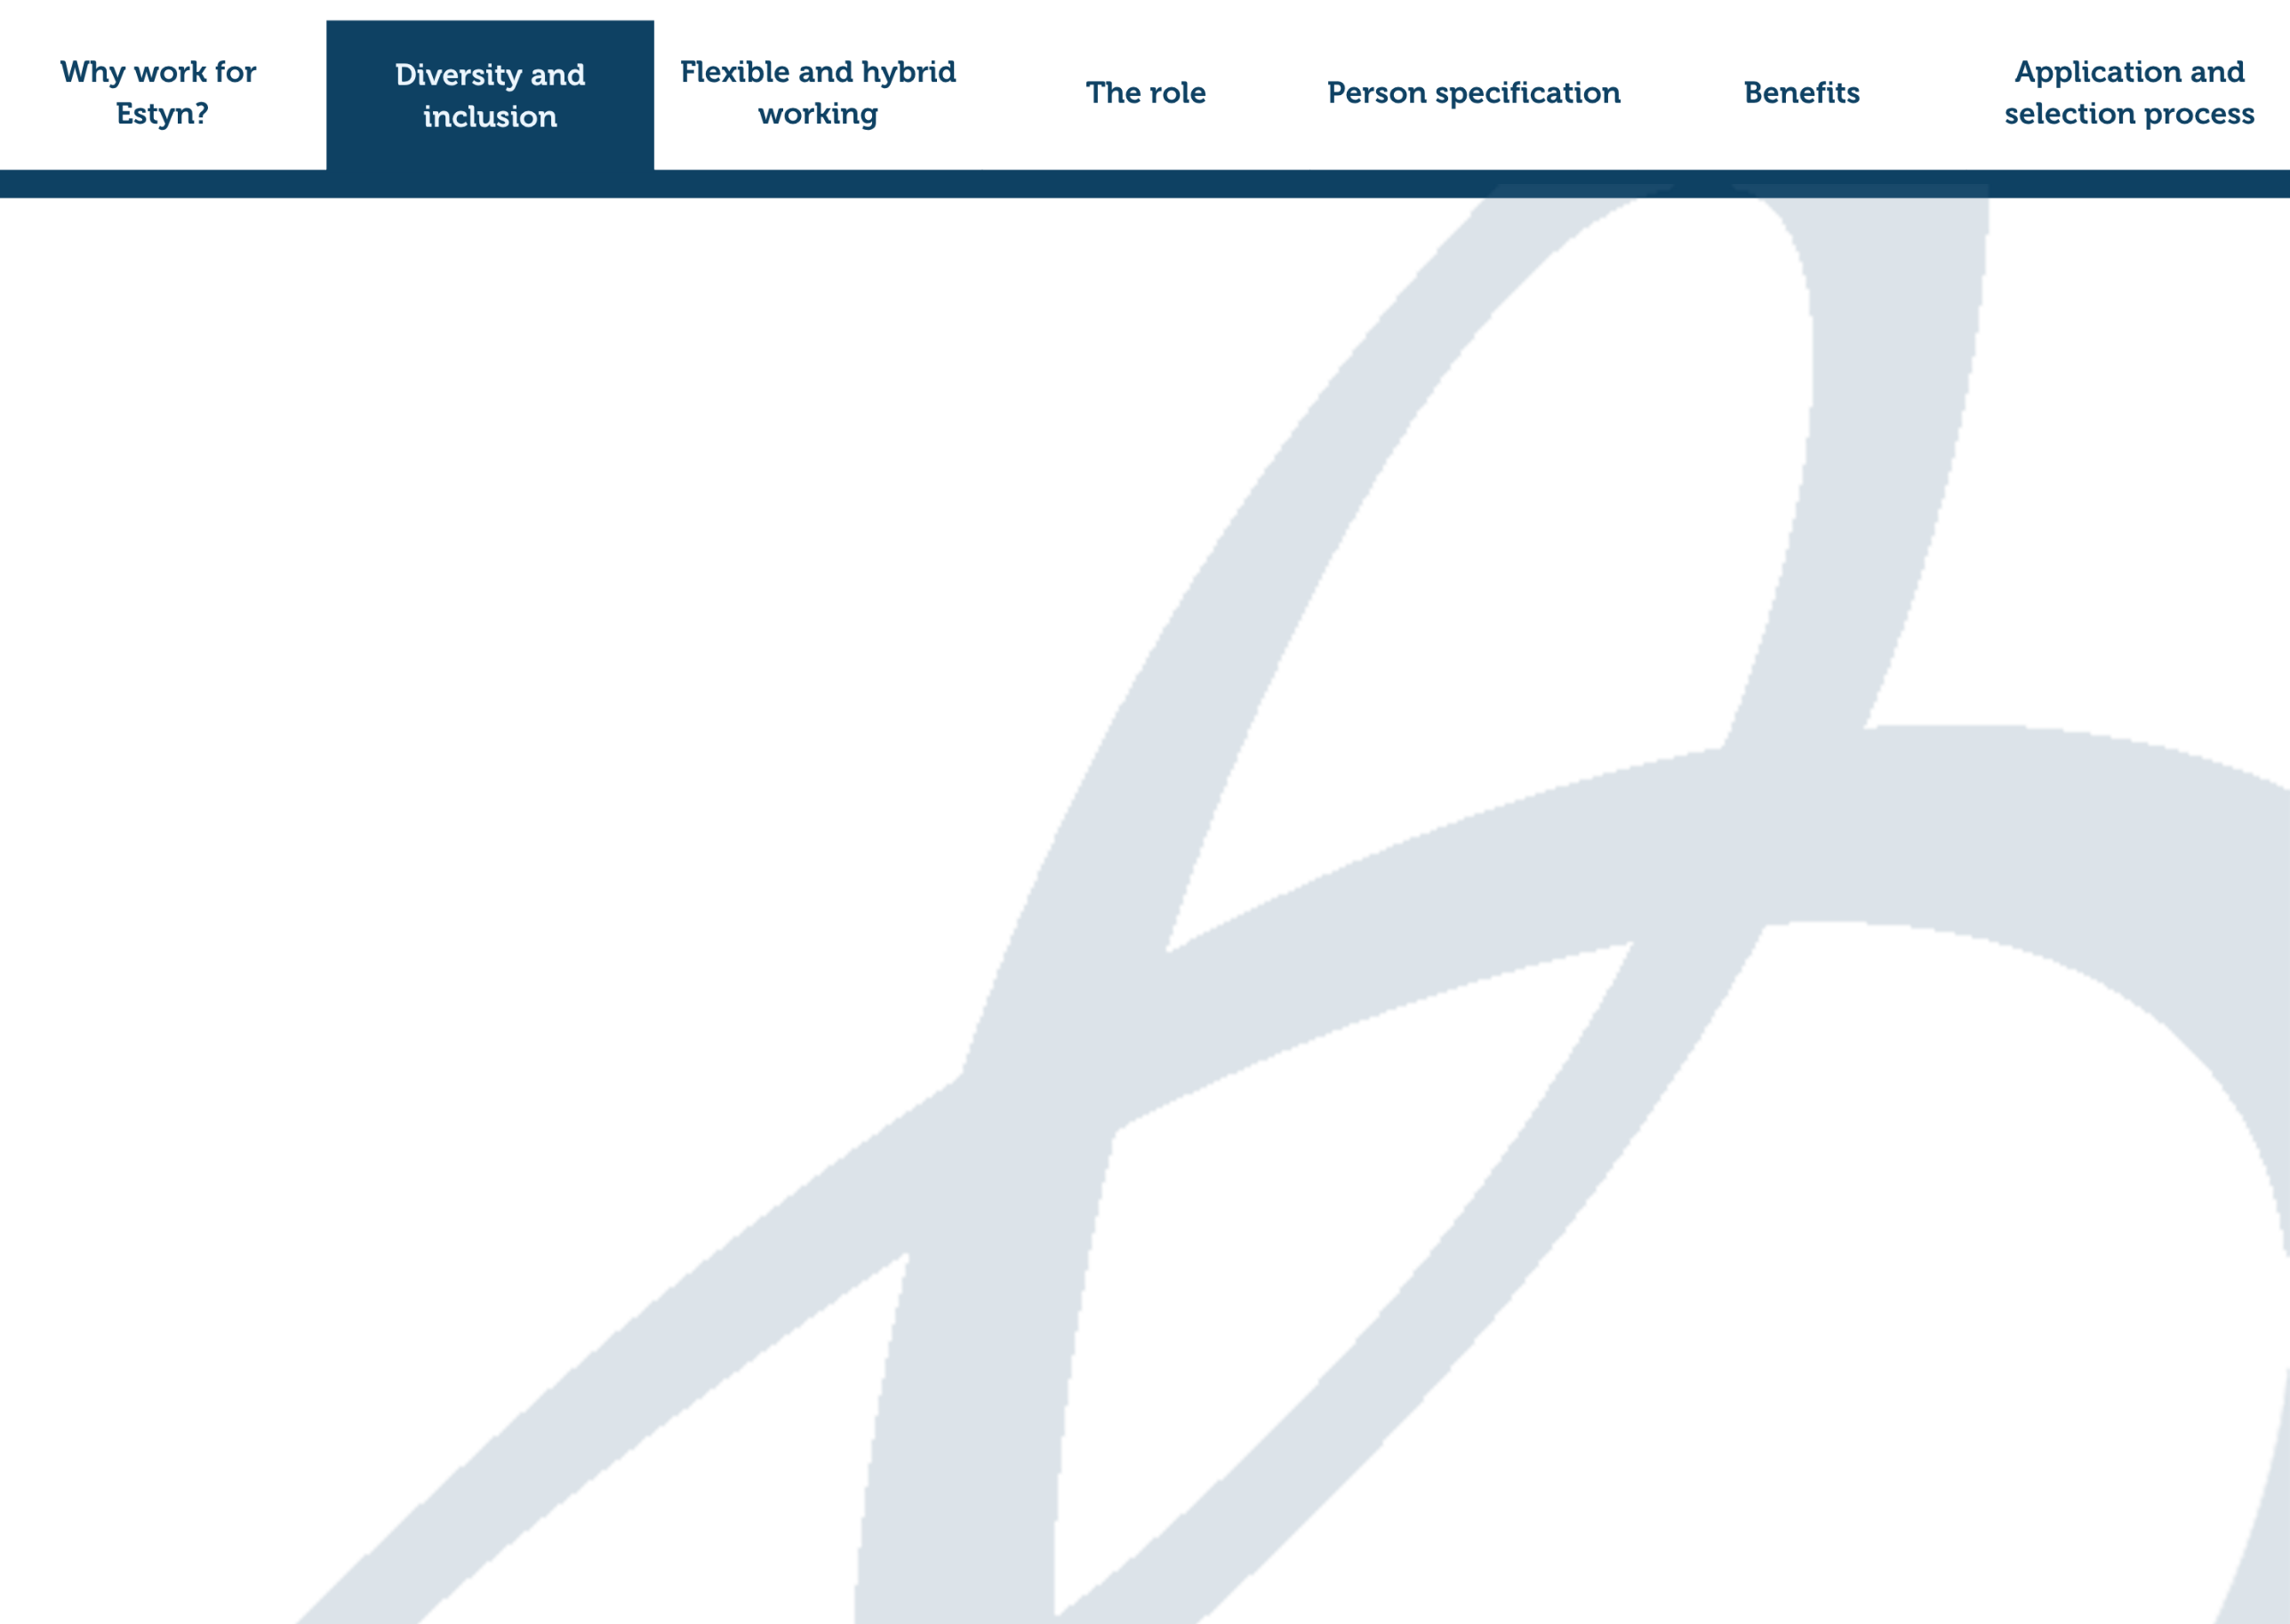
Diversity and inclusion

We’re committed to creating a workplace where everyone feels welcome, supported, and able to thrive. At Estyn, we value different perspectives and lived experiences which help us grow stronger as an organisation and make better, more informed decisions for the learners and communities we serve.
We know that a diverse team brings fresh ideas, richer conversations, and stronger outcomes. That’s why we encourage applications from people of all backgrounds, cultures, and experiences.
A key strategic priority is to increase the diversity of our workforce. Our commitment to recruiting and attracting diverse talent extends to actively encouraging applications from underrepresented groups including ethnic minority, and disabled people. We adopt inclusive recruitment practices including blind shortlisting of candidates and are proud to be a disability confident employer, offering support with adjustments through our process to make sure you can be at your best.
By working together and celebrating what makes each of us unique, we can continue to make a meaningful difference to education in Wales.



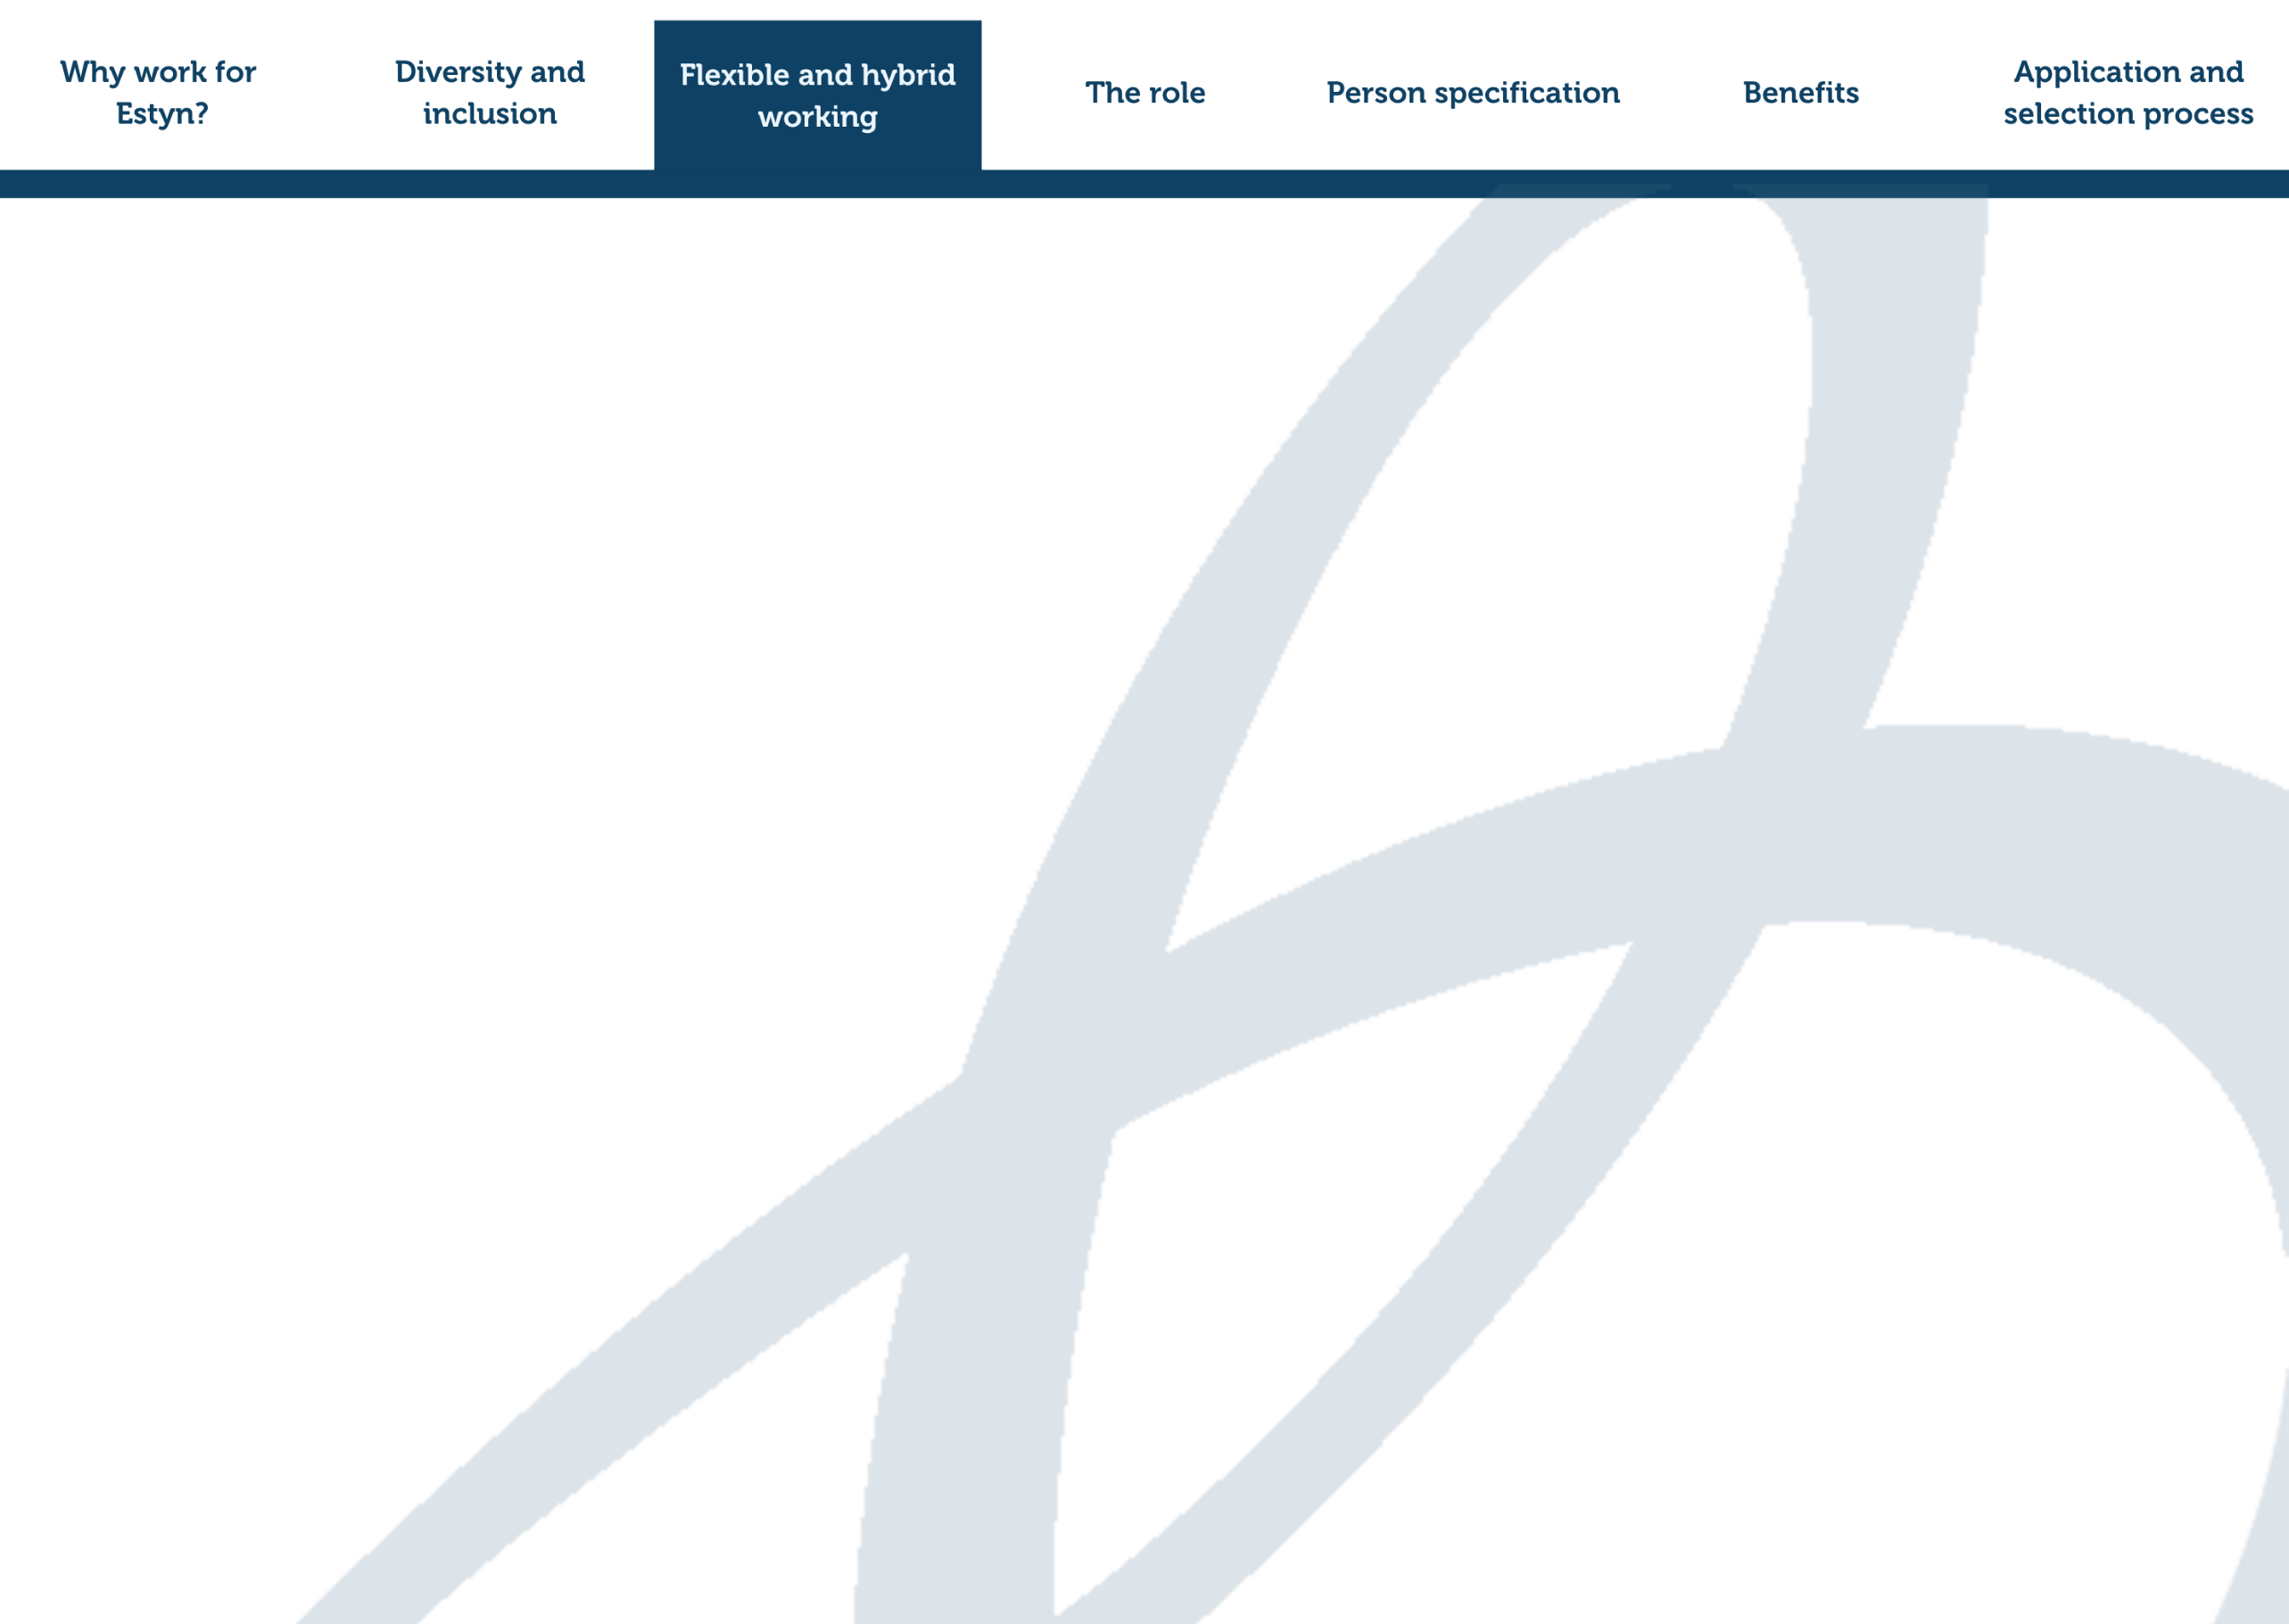
Flexible and hybrid working

At Estyn, we believe flexibility helps our people do their best work while maintaining a healthy work-life balance. That’s why we support a hybrid working approach for our Central Services team.
Typically, this means working from home, with one set day in the Cardiff office as a team day. It’s a great opportunity to collaborate, catch up in person, and stay connected. There is also the flexibility to work more in the office should that be your preference.
We also hold Central Services get-togethers and all-staff conferences throughout the year to bring everyone together, share updates, and strengthen our sense of community.
We operate a flexitime system too, giving you even more freedom to shape your working day in a way that suits you and meets business needs.
It’s all about trust, balance, and supporting each other to work well, wherever we are.

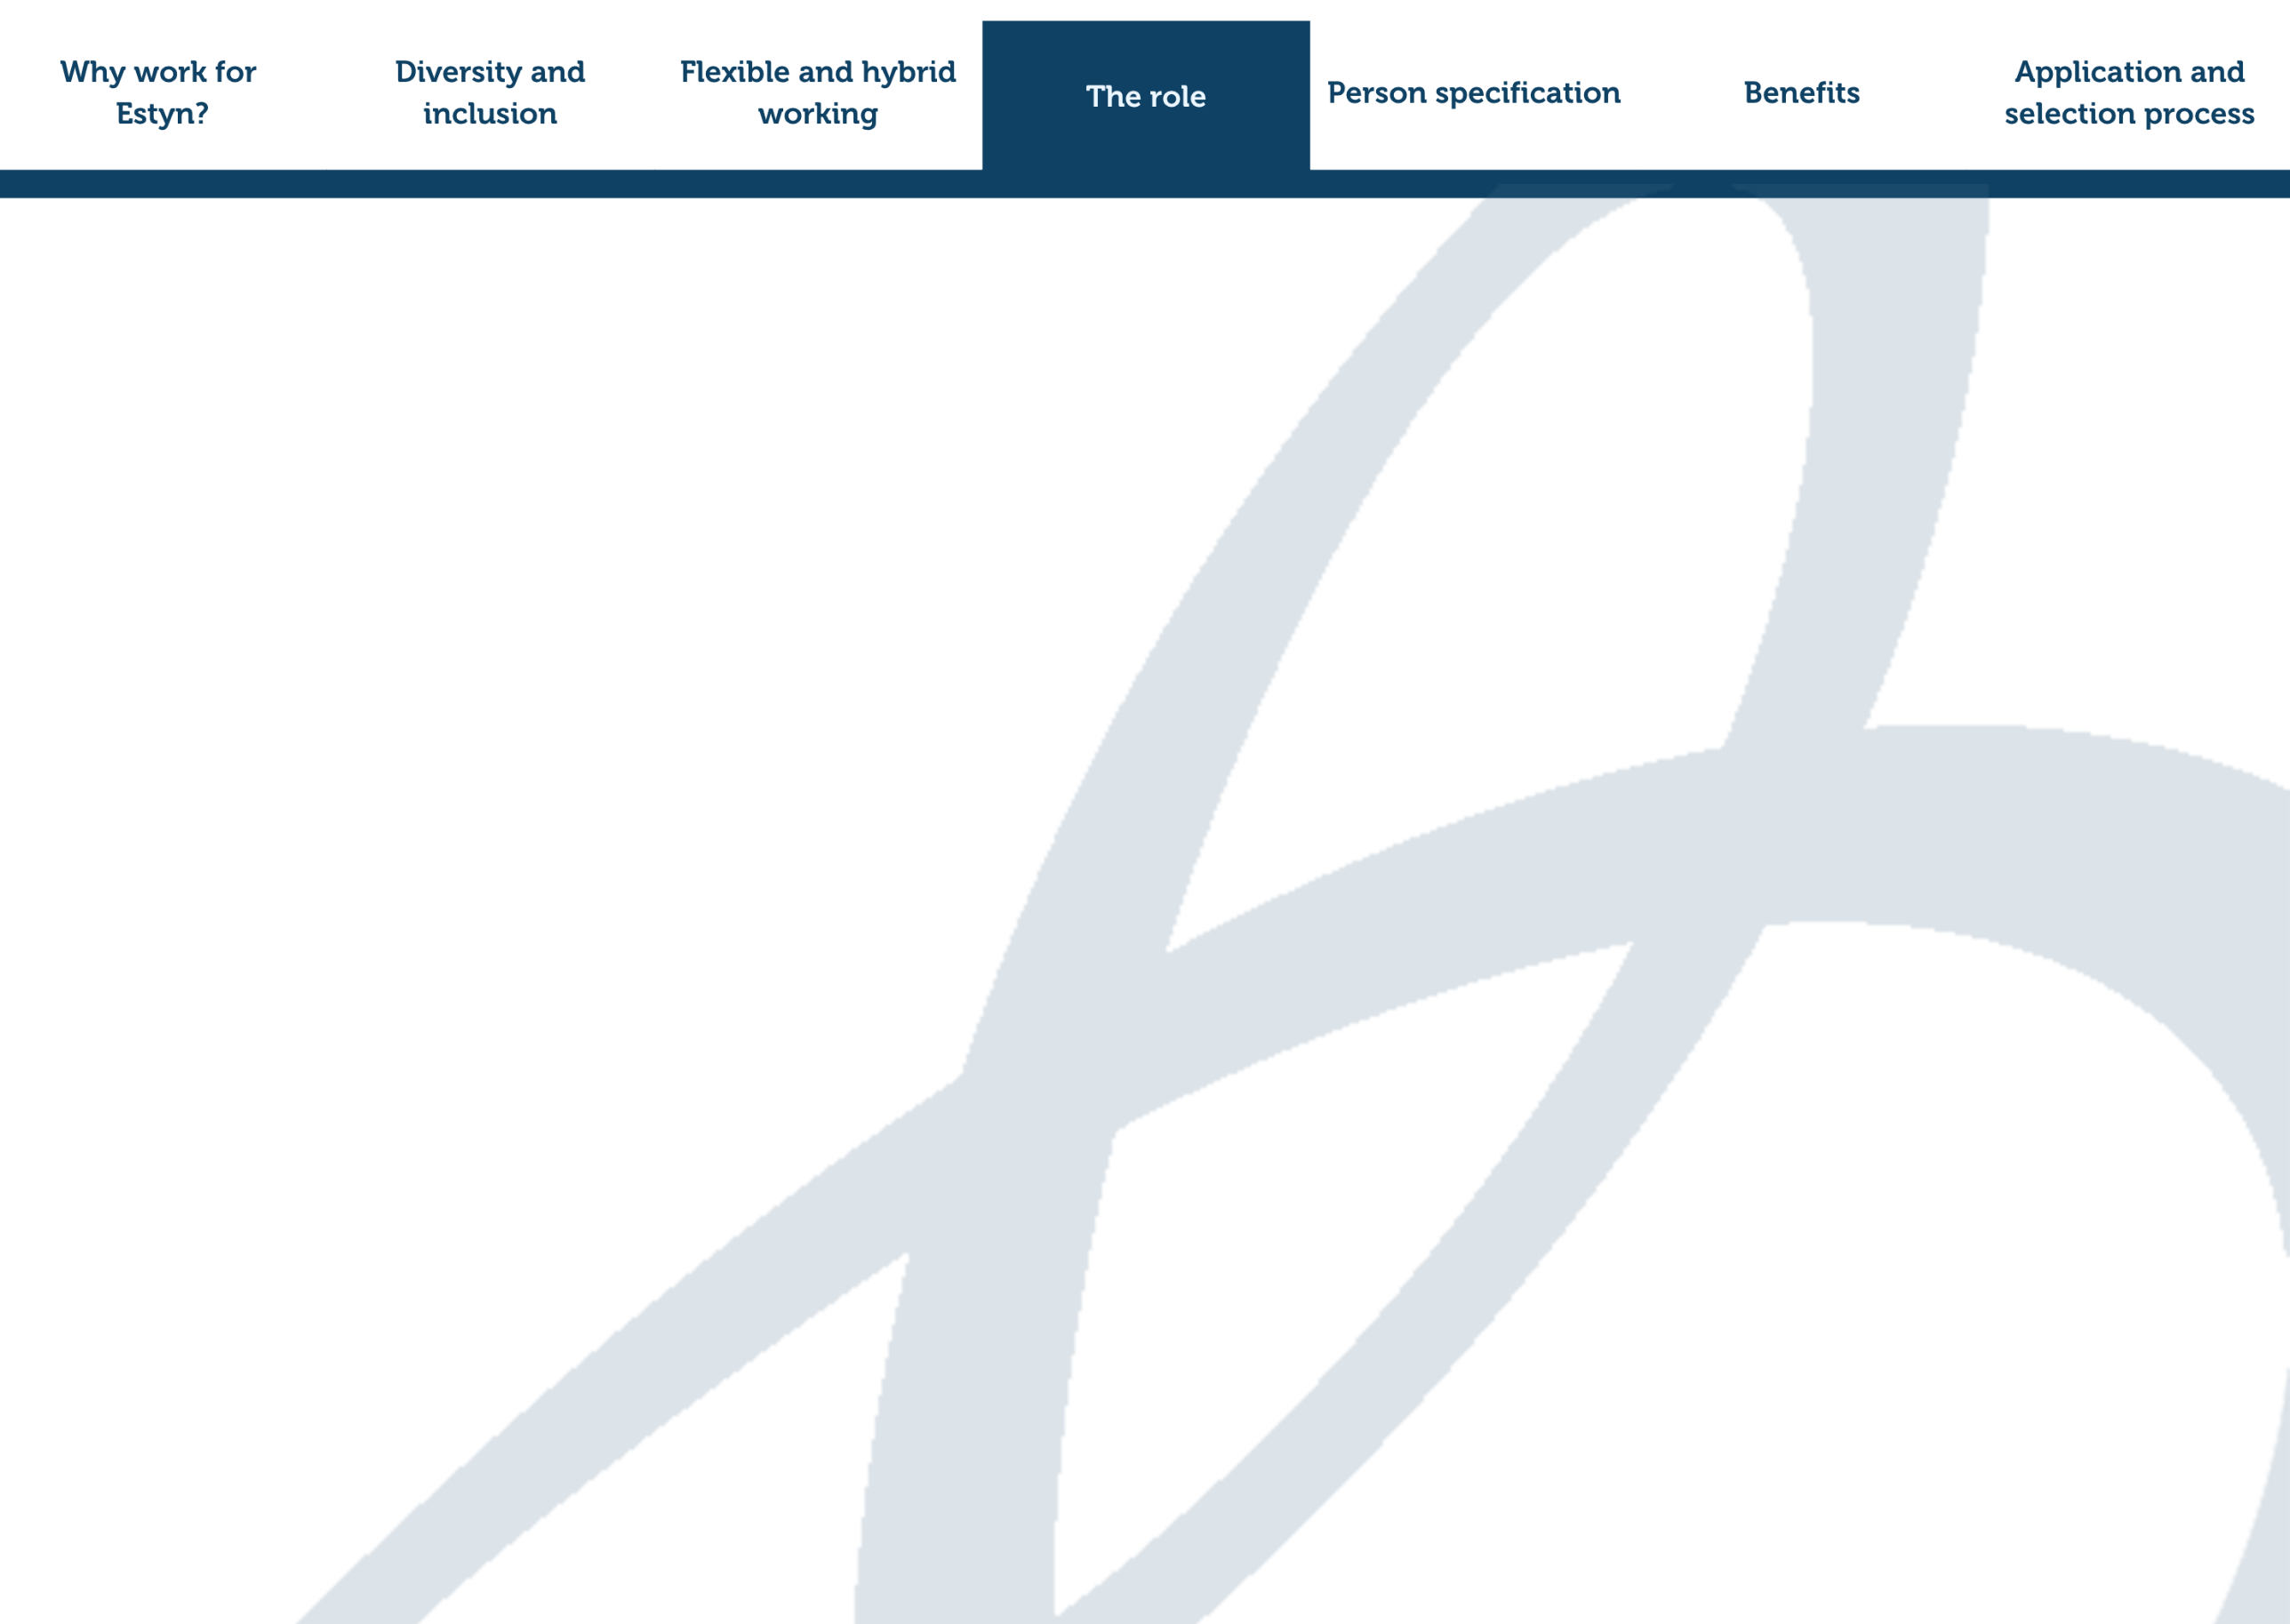
Who we’re looking for

We are looking for a creative communications professional with strong digital skills, able to produce engaging, accessible content, work confidently in Welsh, and collaborate effectively to support Estyn’s communications and strategic aims.
Key tasks include:
- Support the development and evaluation of communication campaigns to raise awareness and understanding of Estyn’s work and build brand visibility.
- Draft multi-channel content plans to support the promotion of our inspection arrangements, improvement resources, key publications, recruitment campaigns, and other specified areas of our work.
- Design relevant, engaging and creative content for internal and external audiences for use across a mix of communication channels, including our website and social media channels.
- Lead on horizon scanning across social media; identify and share trends and opportunities to highlight our work creatively on new channels such as Instagram, TikTok and other identified platforms.
- Provide management reports and analysis on website use, social media engagement and marketing campaigns to evaluate effectiveness and inform continuous improvement.
- Support our proactive and reactive media relations, being the first point of contact for media enquiries, drafting press releases and preparing briefings for interviewees.
- Support the coordination of key corporate announcements, working with the PR & Campaigns Manager to deliver the targeted distribution of press releases, stakeholder toolkits, e shots and other promotional materials.
- Lead on the planning, collation and drafting of the half termly external newsletter Datgan.
- Manage the blog schedule, editing and publication process.
- Champion and support Estyn's tone of voice, brand guidelines and accessibility guidelines, working with managers plan content and ensure coherent messaging and branding across all of Estyn’s communications channels.
- Undertake any other duties as may reasonably be required by managers.

Person specification

It’s essential that you:
- Are able to work through the medium of Welsh.
- Have relevant experience or a qualification in a communications environment.
- Have relevant experience of developing digital content for a range of channels to support communications objectives.
- Have good digital skills including experience of working with social media management platforms and basic knowledge of supporting the maintenance of websites and using Content Management Systems.
- Experience of analysing data to inform campaign evaluation, using a range of available sources.
- Have practical understanding of how print, broadcast and digital media work with experience of drafting press releases and developing relationships with journalists and other media contacts.
- Have strong written skills with proven experience of copywriting and are able to translate and present technical/specialist information into plain English.
- Have good IT skills (including Microsoft Office).
- Are able to work independently, use initiative and work collaboratively across the organisation.
- Have excellent organisation and time management skills, juggling competing priorities when needed.
It’s desirable that you have:
- The ability to work professionally with a range of stakeholders.
- Experience in supporting the delivery of internal communications.
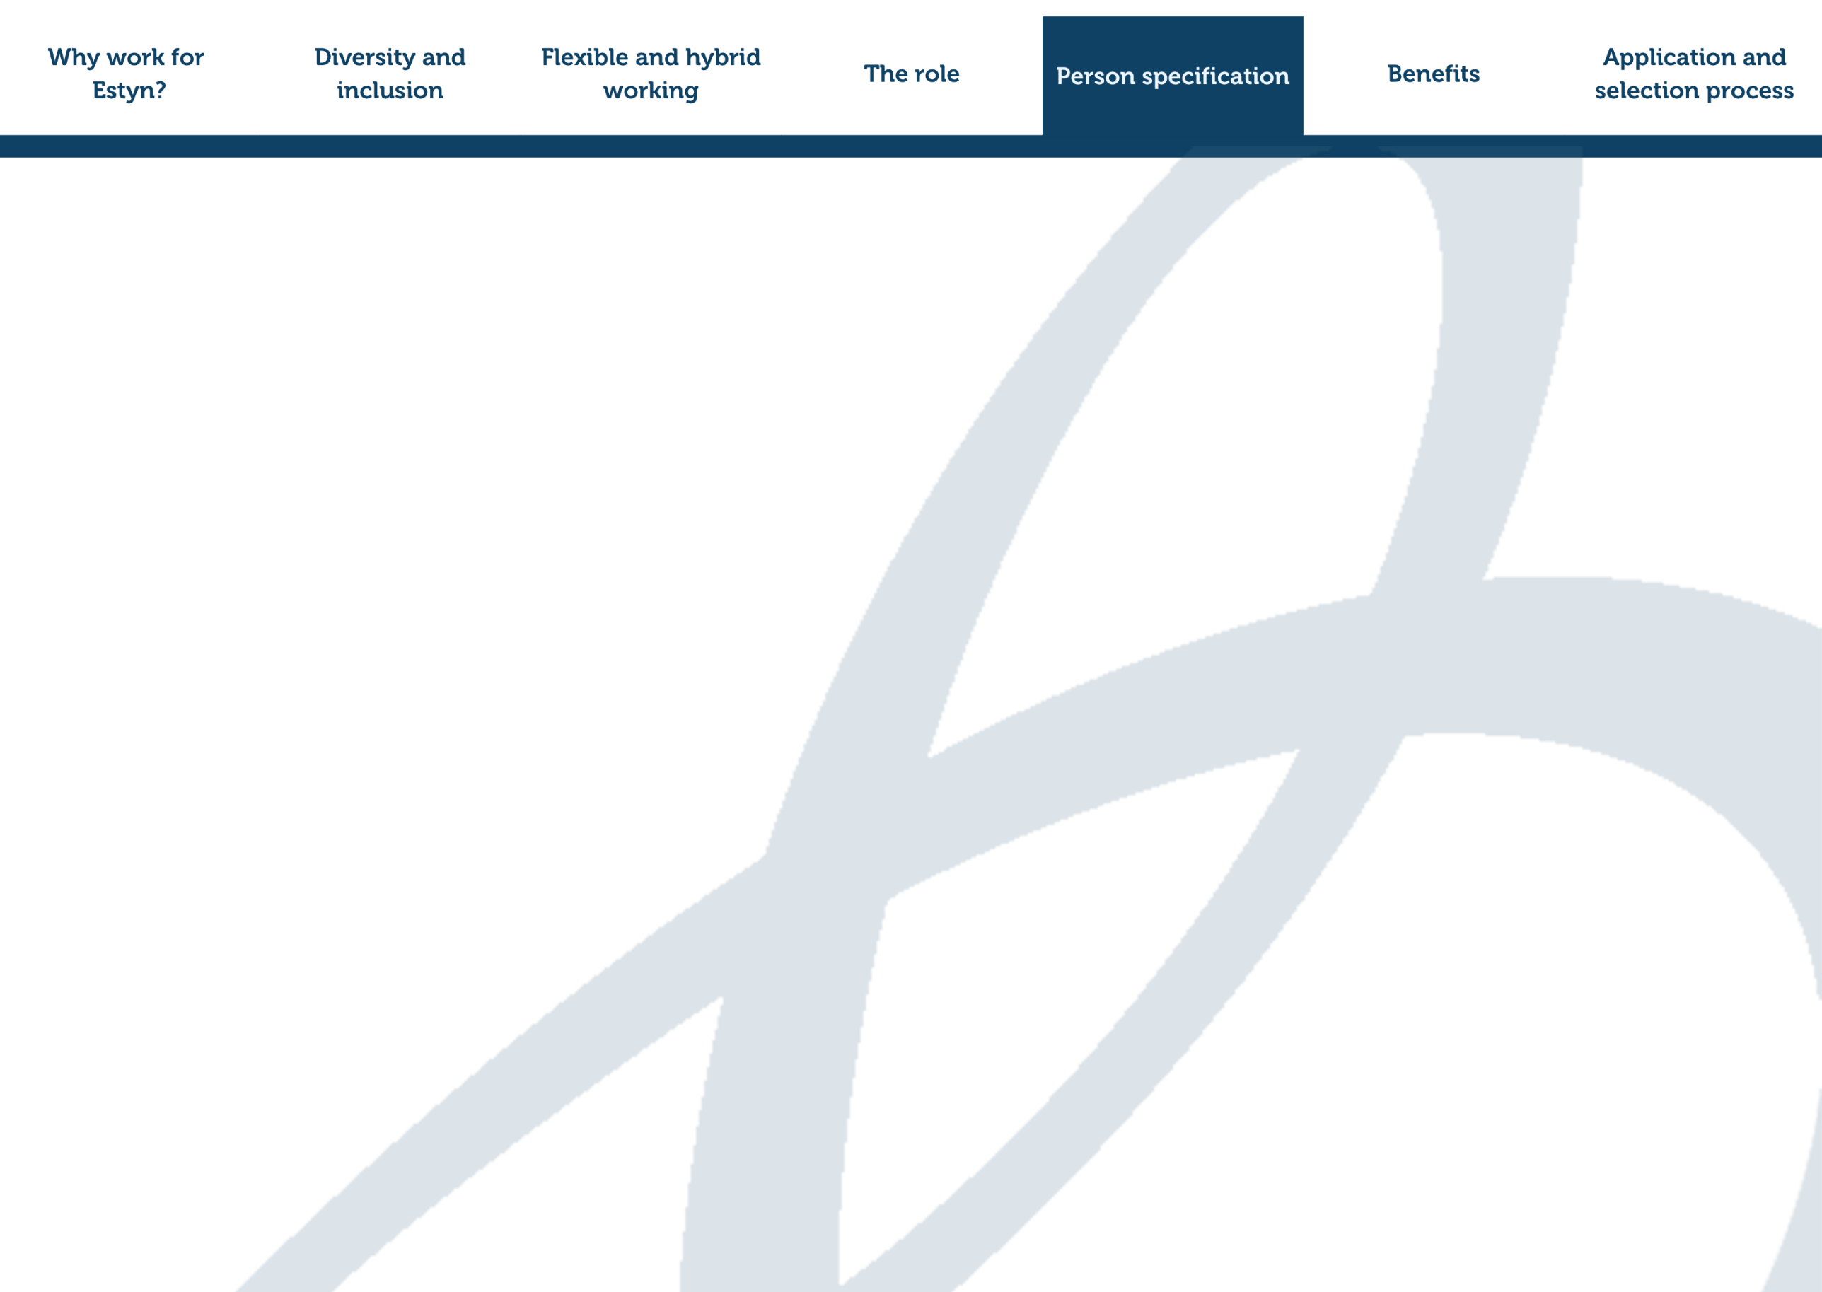
- Knowledge of industry trends and emerging technologies in digital communications

Person specification continued.
Key behaviours
- Communicating and influencing
- Changing and improving
- Working together
- Delivering at pace

You can find more information and examples of these behaviours in the Success Profiles - Civil Service Behaviours at Grade EO.

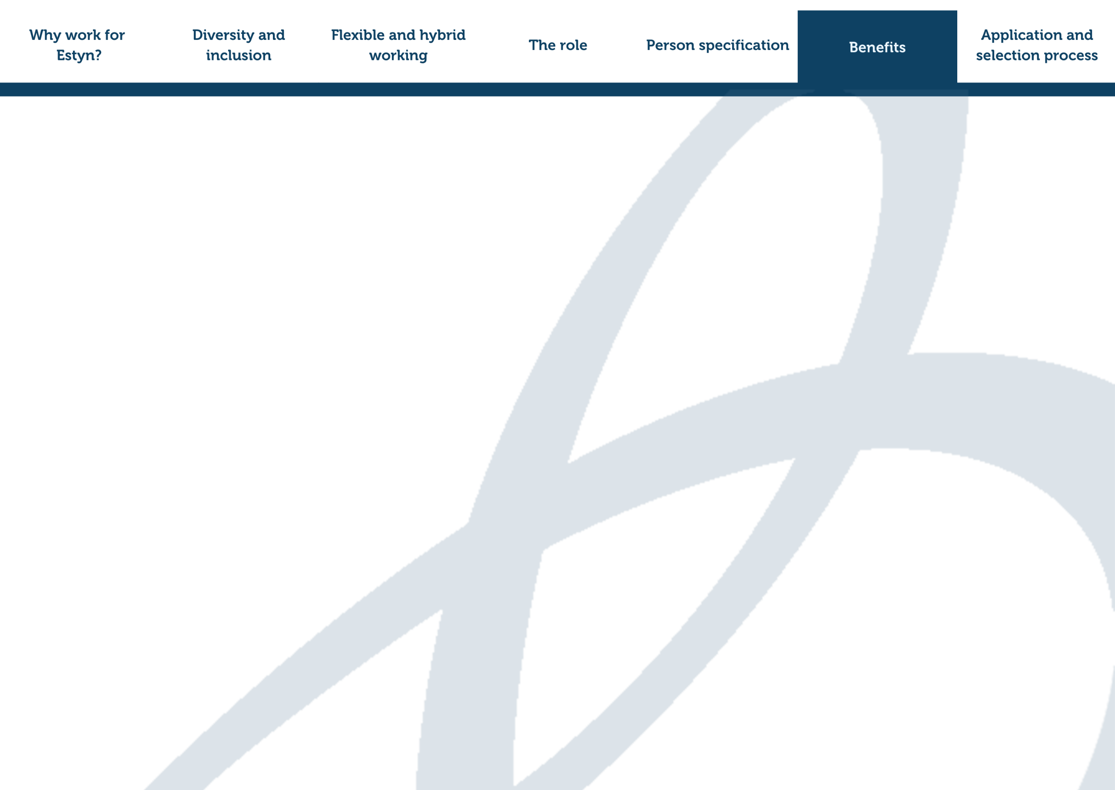

Benefits of joining Estyn

In addition to a good work/life balance, job satisfaction, a supporting culture, ongoing learning and development opportunities and professional development, you can also expect other benefits, including the following:
- Competitive salary and incremental points meaning that you will normally reach the maximum of the pay scale within two/three years of joining us.
- Generous holiday entitlement – 41 days away from work each year (made up of 31 days of annual leave, plus 10 public/privilege holidays (pro-rated for those who work part-time).
- Flexible working - We operate a flexi-time system, giving you the freedom to shape your working day in a way that suits you and meets business needs.
- Excellent pension - When you join Estyn, you’ll automatically become part of the Civil Service Pension scheme, one of the most valuable pension schemes in the UK. We invest in your future by contributing 28.97% of your salary which equates to £8,913 per year, helping you build a strong and secure pension for later in life.
- Support for your wellbeing – We provide an hour of wellbeing time per week (pro-rated) for staff. We also provide an employee assistance programme, free annual health checks, seasonal flu jabs, a free eye care scheme and access to Health Insurance Plans through Civil Service Healthcare.
- Support for your family life – generous family friendly policies including maternity, paternity, adoption leave.
- Tax-free savings – Access to a cycle to work scheme.
- Special offers and discounts – Access to a range of discounts and exclusive offers through the Civil Service Social Club – Sports and Leisure, the Civil Service Motoring Association, the Civil Service Insurance Society and the Charity for Civil Servants.

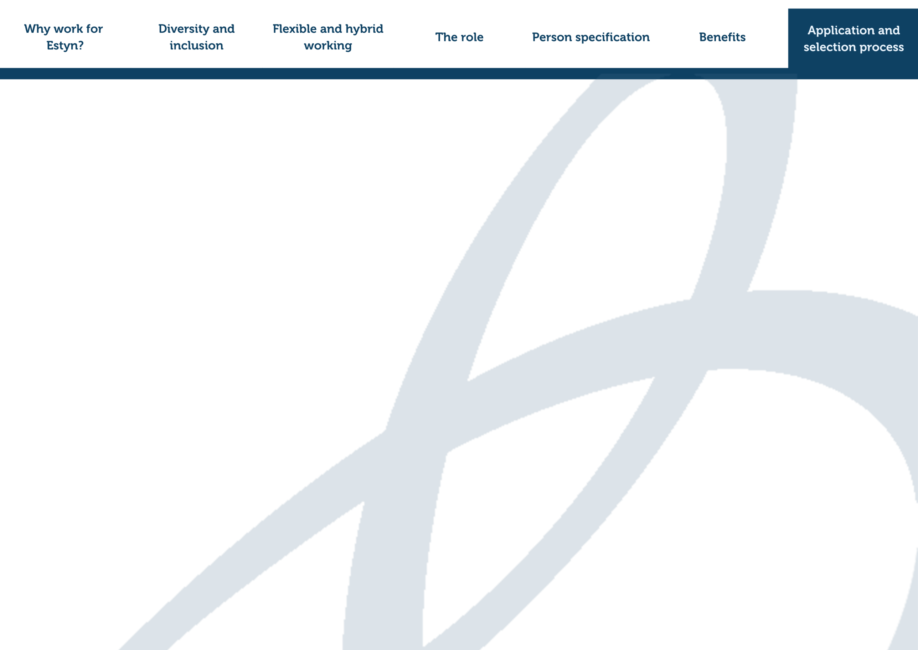
Apply now!

Enquiries: If you have any questions about the role, please contact Louise Yau on louise.yau@estyn.gov.wales.

Apply online: To apply for the role please visit - JobBoard (estynpeoplehr.cymru).

Closing date: 10am on 9 February 2026

Alternative arrangements or accessible documents: If you’d like to apply or access this document in an alternative format, please contact us to discuss your requirements.

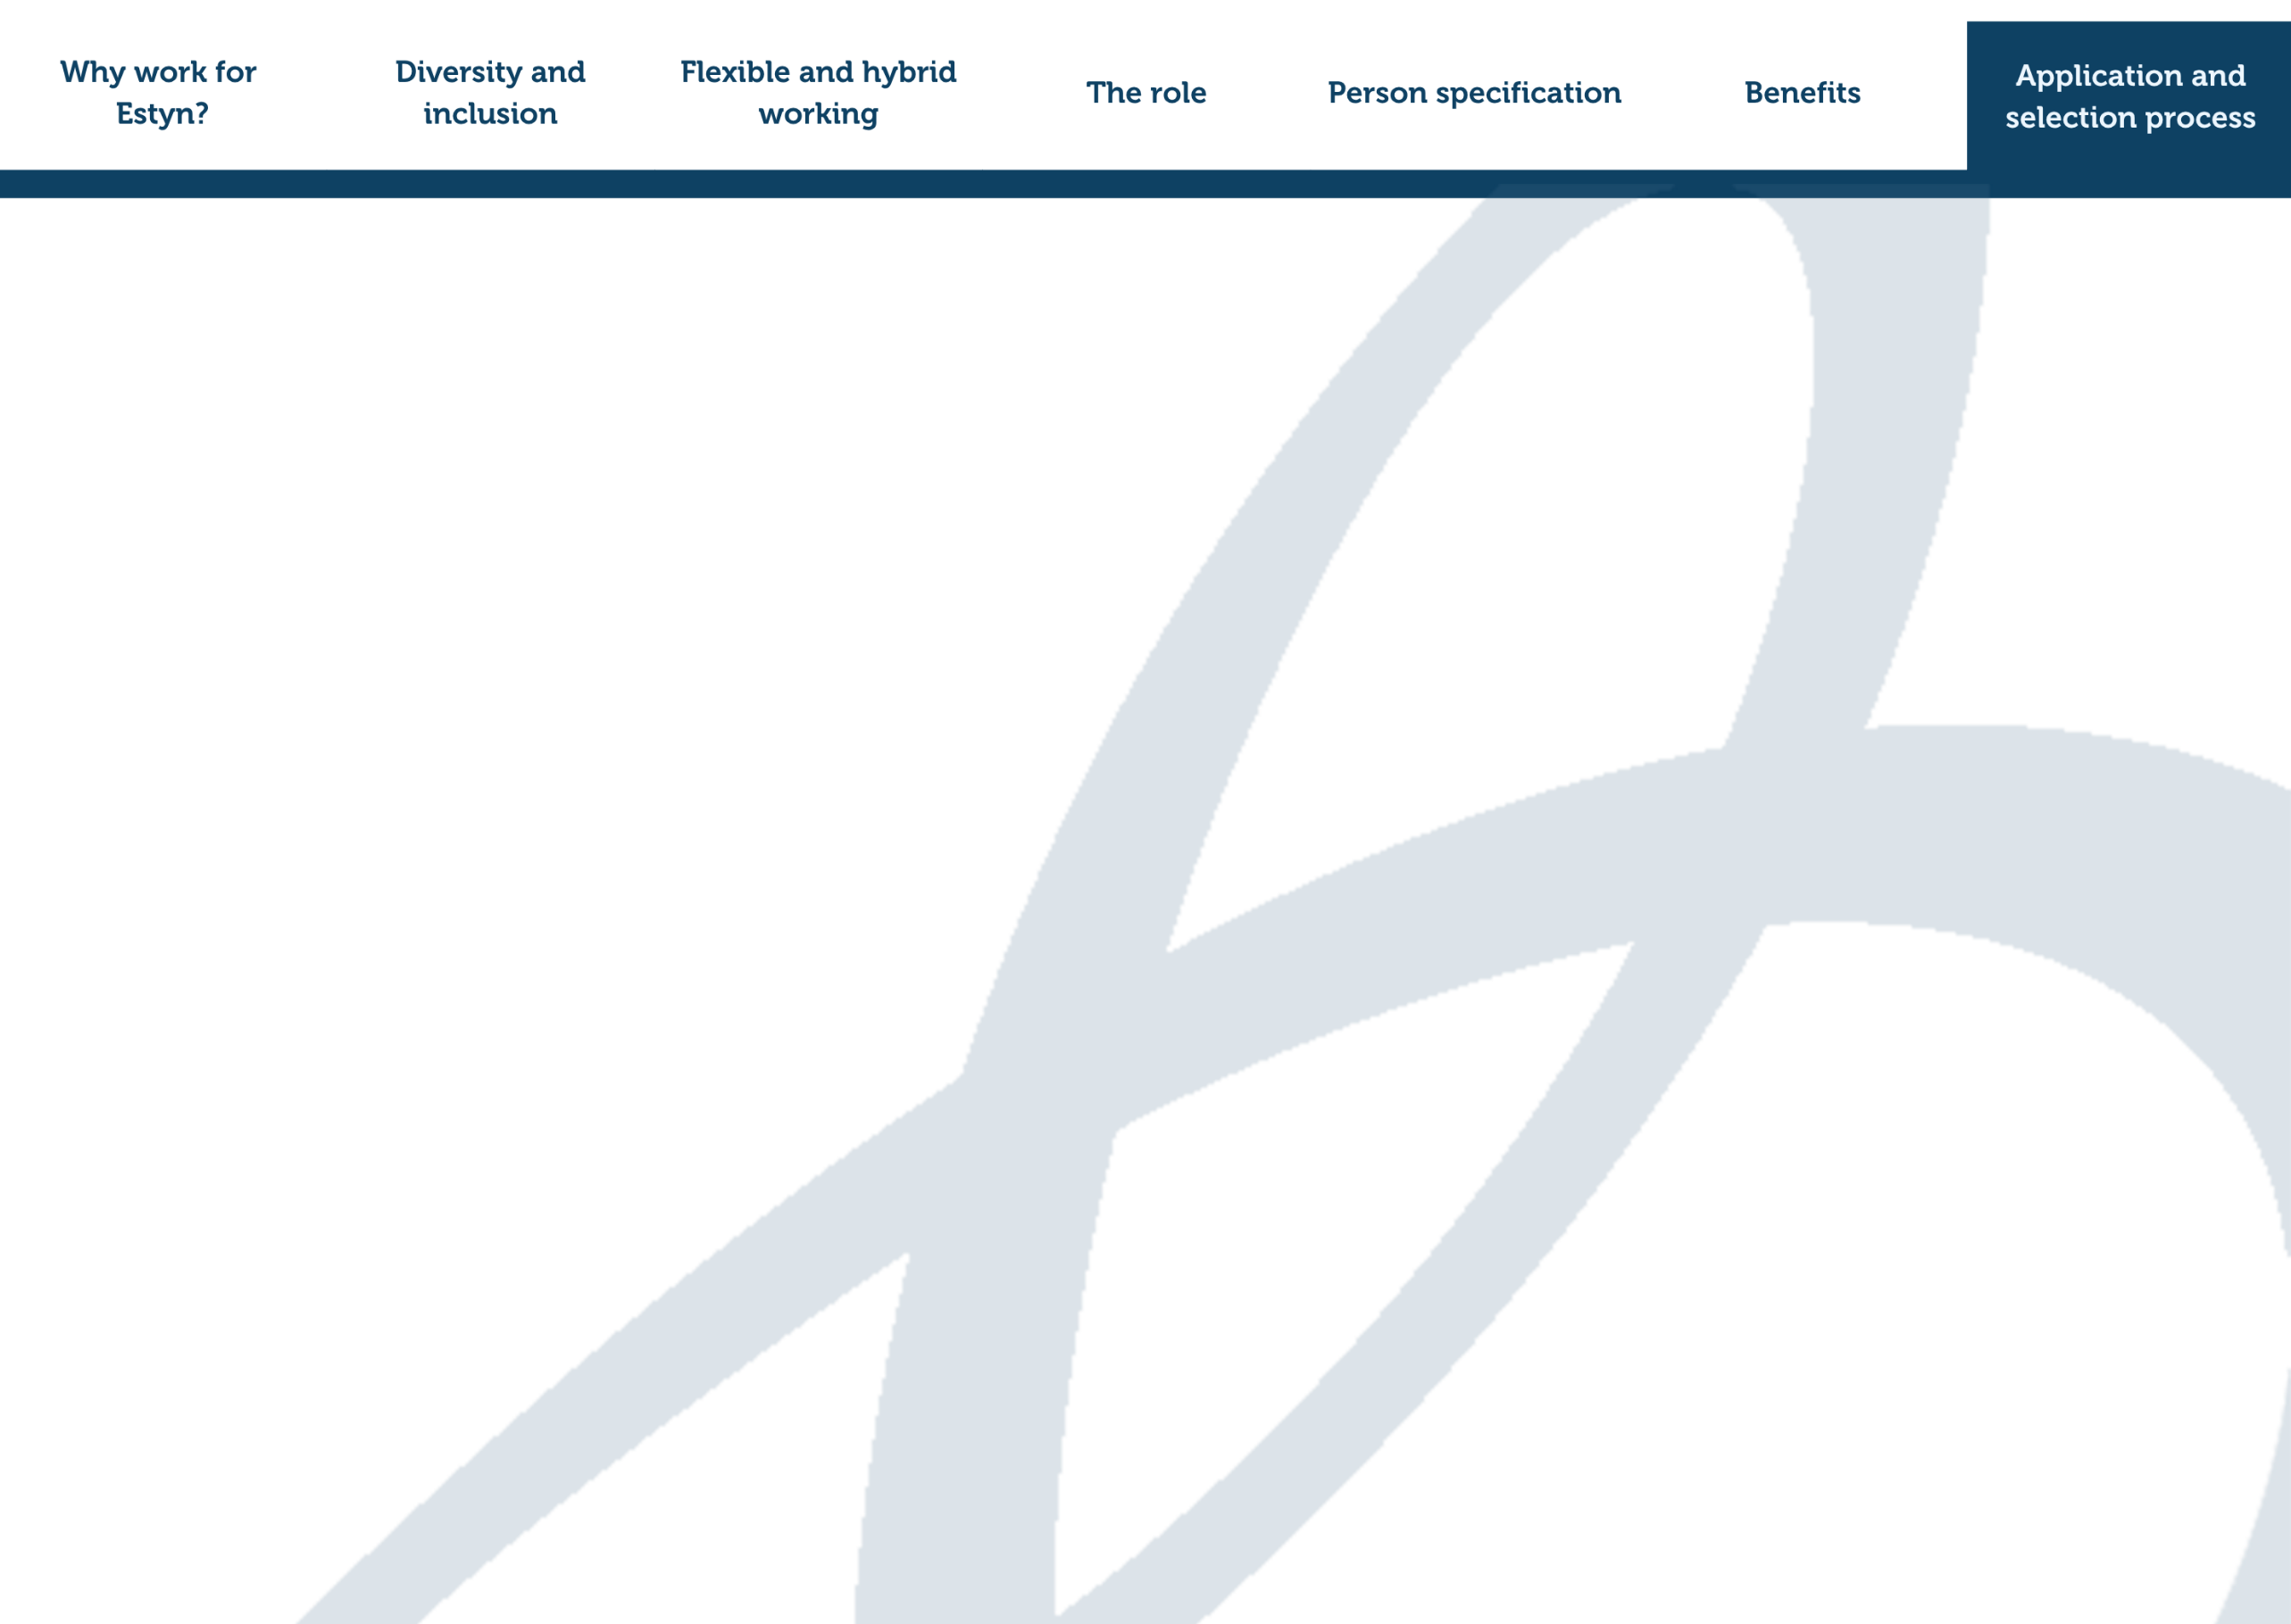
Selection process and key dates

You are able to apply in Welsh or English. An application submitted in Welsh will not be treated less favourably than an application submitted in English. Your application may be translated into Welsh or English (depending on the majority language of the panel).

The selection process includes:
- A sift of applications: The panel will consider all complete applications. The information you give us in your application is important in deciding whether we will invite you to the next selection stage. Candidates will be assessed at sift on all essential criteria as per the person specification. Desirable criteria will be assessed at sift where there is a strong field of candidates as a second stage after essential criteria have been considered.
- Assessment and Interview: Candidates invited to assessment and interview will be assessed on their skills, experience and behaviours in relation to the person specification. The assessment will consist of a written task relevant to the role, as set out in the job description. The task will assess candidate’s ability to develop high-quality bilingual content. Full details of the assessment will be shared with candidates when they are invited to interview. The interview will consist of a panel interview and will take place 19/20 February 2026.
Future vacancies and reserve lists: If you are appointable, but there isn’t a suitable post immediately available, we may add you to a reserve list. The reserve list is valid for up to twelve months from the date we confirm the outcome of your application. The outcome email will confirm if you are on a reserve list. If a suitable vacancy occurs during that period, we may recommend you for appointment. We appoint from the reserve list in merit order.

Artificial Intelligence

Artificial Intelligence (AI) tools can be helpful in various stages of applying for a job. You could use AI as a tool to research Estyn and the job you’re applying for. You could also use it to organise your thoughts, refine your writing or to help you prepare for an interview. We are keen to get to know you as a person so you must ensure AI aided content maintains your authenticity.

You must not use AI tools to:
- Exaggerate qualifications
- Misrepresent your experiences
- Copy and paste generic responses without editing them to ensure they are appropriate for you and the role you are applying for.

How we use AI
At Estyn, we may use AI to generate ideas for Job Adverts, Job Descriptions, assessments, and interview questions, but we will never use AI tools to make selection or hiring decisions.

Recruitment principles

Our recruitment processes are based on the principle of selection for appointment on merit on the basis of fair and open competition. We follow the Civil Service Commission’s Recruitment Principles.

Our recruitment processes also align with the civil service code, which forms part of the terms and conditions of every civil servant.

The Civil Service Code outlines the core values of the Civil Service:
- Honesty
- Integrity
- Impartiality
- Objectivity

If you feel we have not treated your application under the Principles or the Civil Service Code and you want to make a complaint, in the first instance please contact Estyn’s recruitment team.


If you’re not satisfied with the response you receive from us, you may be able to ask the Civil Service Commission to consider your complaint further.

